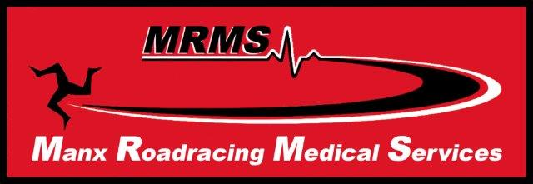
The DBS TT Trauma Symposium
for all 2019 TT course doctors, paramedics, nurses, TMs and all providers of care to
Isle of Man Motorsport events
kindly sponsored for the 8th year in succession by
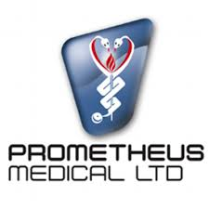
Sunday 2nd June 2019 0830
at Keyll Darree Education Centre, Nobles Hospital, Isle of Man

0830 Registration, tea/coffee/etc
0850 Welcome on behalf of Manx Roadracing Medical Services Dr Sally Simmons
0900 Flying Medics - the Pilot’s perspective. Captain Andrew Bushby
0935 The Russell Perspective - Drowning: a case history. Dr Malcolm Russell
1010 What’s Next…? The Surgeon’s Persepctive Mr Fady Narouz
1045. Coffee and Prometheus exhibition/ practical. AlMcLean and Malcolm Russell
1125 The Paramedic’s Perspective. Al McLean
1200. Case Studies 2018/2019. Dr Gareth Davies
1225 Closing address and updates on MRMS. Dr Gruff Evans
1235 Exhibition and sandwich lunch

Certificates of Attendance will be emailed after the event. Please supply email address on the sign in sheet if you would like the Certificate.

