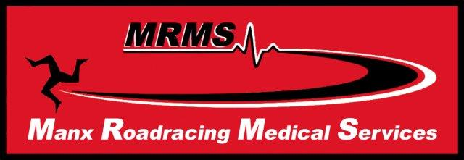
The 7th DBS TT Trauma Symposium
Sunday June 3rd 2018
Keyll Darree Education Centre, Nobles Hospital, Douglas, Isle of Man
Kindly sponsored by Prometheus Medical Ltd
Programme
0815 Registration
0830 Welcome and Introduction Dr Sally Simmons
0840 The Dr John Hinds Memorial Lecture Dr Rudi Auen
0915 Interactive Trauma Care Presentations
- Practical Lessons from the Road Dr Malcolm Russell

0945 Taping the Riders – Pearls and Pitfalls Isla Scott
1015 Coffee and Prometheus kit demonstration Dr Malcolm Russell
1045 Pre-hospital polytrauma care Dr Oli Hautmann
1115 Case Histories from 2017/discussion Dr Gareth Davies
1215 Closing Address Dr Gruff Evans
1220 Lunch and Dispersal
If you require Certificates of Attendance they will be emailed after the event. Please supply email at Registration.
